Ujjwal Pandey

ujjwalpandey.aps@gmail.com

Whose app

This web app is created for an offline to institute increasing the reach.

**User -Faculty Institute Workspace**

Java Web-App

*User-Faculty Institute Workspace*

Developed by

**Name: Ujjwal Pandey**

**Registration no: S190020100476**

**Contact: +91 8375990500,**

**ujjwalpandey.aps@gmail.com**

**Batch Code: B210357**

**Start Date: 03/04/2021**

**End Date: 23/04/2021**

**Name of the Coordinator: Sandhya sri Angara**

**Name of the Developer: Ujjwal Pandey**



**Date of Submission**: *17-05-202*

**TABLE OF CONTENTS**

**Page No.**

1. Introduction of Project ….03
2. Objectives of Project ….04
3. Tools/Platform of Project – H/W and S/W ….05
4. Project plan ….06
5. Design of Project
   1. DFD ….07
   2. ER DIAGRAM ….10
   3. DATA STRUCTURE ….11
   4. Summarizing tables Relationship ….13
   5. Number of Modules & Their Description ….14
   6. Process Logic of Modules ….15
6. Limitation of the Projects ….18
7. Future Scope of Project ….18
8. Table used ….21
9. Output Screenshots ….24
10. Bibliography ….46

**INTRODUCTION**

**Institute Management System**

**Institute Management System** is the software made for the user and faculty to find, manage, and perform a maximum of specific institute related functions. Many modules are included in the software to perform full operation like, For user ‘**student’**: - searching courses, getting full details about the respective course, getting enrolled in the respective course, find details about the institute, get different mean details to connect with the institute in different ways, For user ‘**faculty’**: - they can see no. of students in the institute in a list and details of a student with their specific enrollment number, list of faculties in the institute and their detail, with all these only the owner will be able to add and delete new faculty in the list of the institute having real-time all data visible to him/her.

At very first when a user will open the institute site, the site will open its home page which will contain a nice image with a logo and inspiring line at the center nothing else, but on scrolling it will show other content like achievements, few courses, hyperlink to all the courses page, about the institute and few location contactable details with a hyperlink containing full contact page which will have a form for user or guardian to contact online through an online form, mail, and mobile numbers to contact in the institute to clear all the query.

**OBJECTIVE OF THE PROJECT**

As the title of the project suggests, the objective of this software (web application) is to automate all the works (excluding teaching) of the Institute related to the management of admission getting details etc. Some of the features of this software would be: -

* Creating a system to automate the services offered by the Institute, it would be more flexible than human to human contact as of today’s corona situation.
* It allows a user search for their loved and required course within the institute and get enrolled in it without coming in contact with other humans, and reduce the spread of COVID-19.
* It keeps track of the students enrolled to date and faculty in the institute.

**TOOLS, PLATFORM, HARDWARE, AND SOFTWARE REQUIREMENT SPECIFICATION**

**Tools/Platform**

Project is developed using **Eclipse & MySQL 2017 command line** for storing data.

**🡪Use of Technologies/Tools**

*It is going to be a java web application.*

1. Unconditionally java
2. JSP
3. CSS
4. JavaScript
5. MySQL
6. Hibernate

**🡪Project type**

Java-based web application, created using maven.

**🡪Use of IDE**

Eclipse

**🡪Use of Browser**

Google Chrome, and

Microsoft Edge

**Hardware requirement Specification**

Altogether a Personal Computer with following components**:**

To use Browser on Windows®, you'll need:

* Windows 7, Windows 8, Windows 8.1, Windows 10 or later
* An Intel Pentium 4 processor or later that's SSE3 capable (as we need only a browser)
* 2.7 GHz or faster processor
* 2 GB Memory (RAM)
* Hard Disk 125 GB
* Color Monitor
* Keyboard
* Mouse
* Colored screen

**Software requirement Specification**

The software which was required for using the software is a new advanced **web browser** like Google Chrome, Microsoft Edge, Opera, mac Safari.

**Project Plan**

|  |  |  |  |  |  |
| --- | --- | --- | --- | --- | --- |
| **S. No** | **Task Name** | **Planned Start Date** | **Planned Finish Date** | **Actual Start Date** | **Person Responsible** |
| 1 | Analyze the project requirement | 03/04/2021 | 03/04/2021 | 03/04/2021 | Ujjwal Pandey |
| 2 | Planning | 04/04/2021 | *On every moment of project coding* | 03/04/2021 | Ujjwal Pandey |
| 3 | Execution | 07/04/2021 | 23/04/2021 | 07/04/2021 | Ujjwal Pandey |

*Little changes are done on day to day basic not mentioned project plan date chart.

**CONTEXT LEVEL DFD**

**Created on www.app.creately.com**

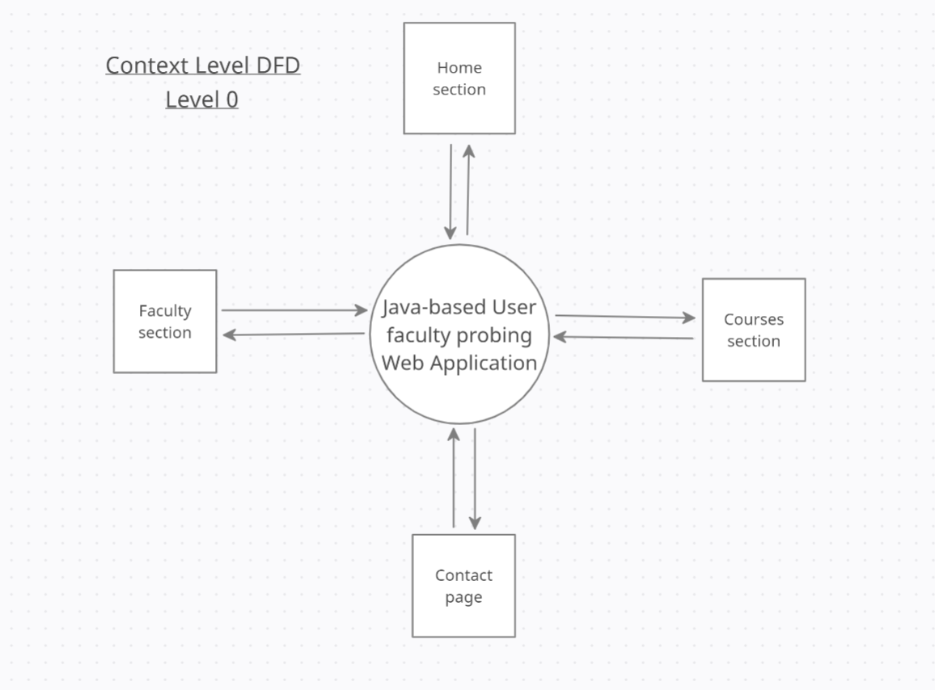

*DFD level 0*

**CONTEXT LEVEL DFD**

**Created on www.app.creately.com**

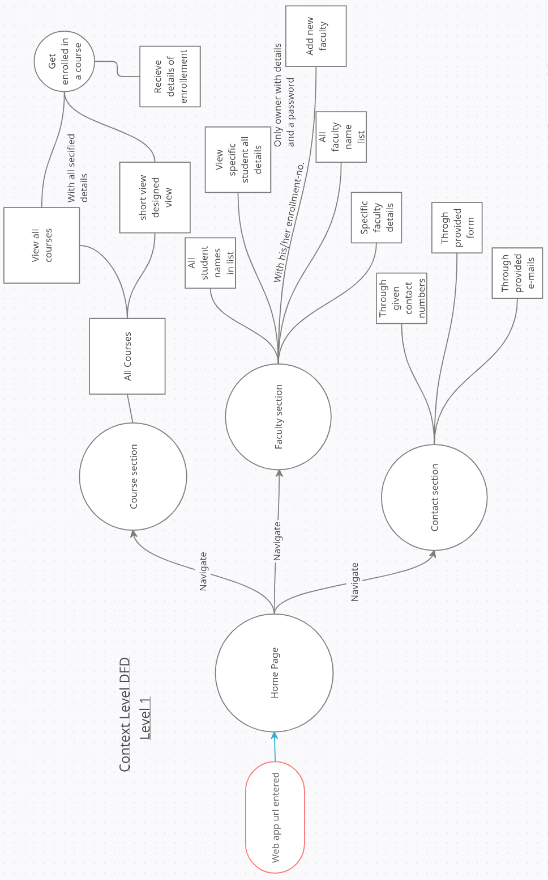

*DFD level 1*

**CONTEXT LEVEL DFD**

**Created on www.lucid.app**

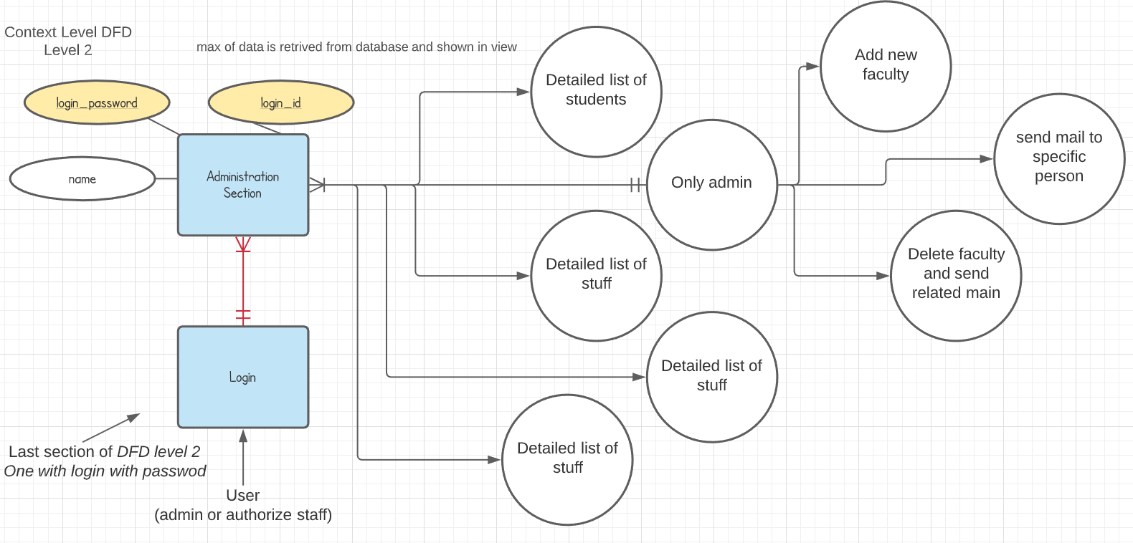

*DFD level-2*

**ER-Diagram**

**Created on www.lucid.app**

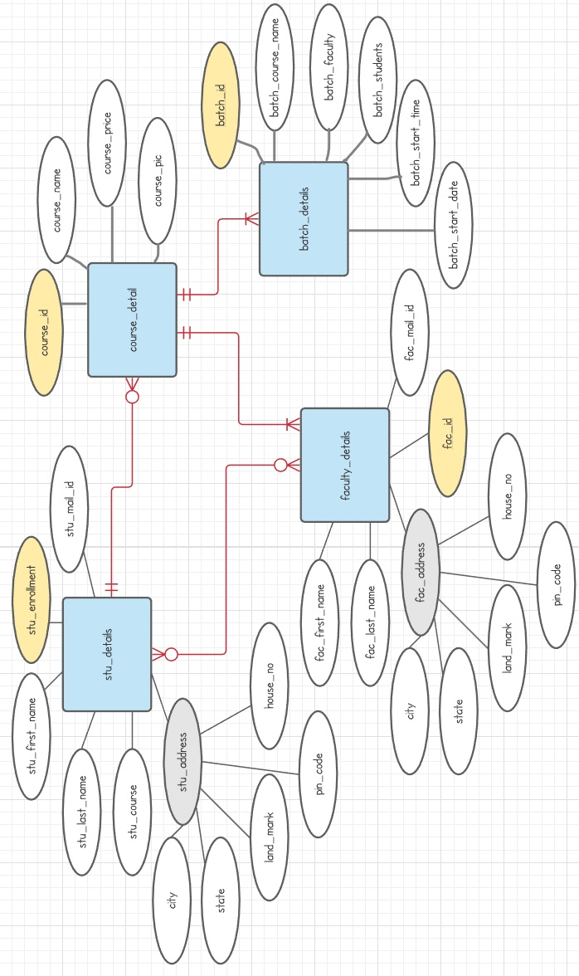

**DATA-STRUCTURES**

🡪 Tables are subject to be increased or decreased while code development.

Table Name: userdetails

|  |  |  |  |
| --- | --- | --- | --- |
| **Column Name** | **Data Type** | **Constraints** | **Description** |
| Email | VARCHAR (255) | primary key  NOT NULL | unique identity of each user |
| city | VARCHAR (35) |  | City where user lives |
| contactNumber | VARCHAR (15) |  | User contact number |
| firstName | VARCHAR (20) |  | User’s first name |
| houseNo | VARCHAR (15) |  | House number of the user |
| landMark | VARCHAR (255) |  | Landmark of use address |
| lastName | VARCHAR (20) |  | User’s last name |
| password | VARCHAR (255) |  | User’s password |
| pinCode | VARCHAR (255) |  | Pin code |
| registrationDate | VARCHAR (255) |  | Date when user registered |
| state | VARCHAR (255) |  | User’s address state |
| userType | VARCHAR (255) |  | What type of user is Admin/Student/Faculty |

Table Name: queryfromform

|  |  |  |  |
| --- | --- | --- | --- |
| **Column Name** | **Data Type** | **Constraint** | **Description** |
| qSoNo | Int | PRIMARY KEY  NOT NULL | Unique id of query |
| qContact | VARCHAR (255) |  | Contact details given by person submitting query |
| qEmail | VARCHAR (255) |  | Email id provided by the person querying |
| qName | VARCHAR (255) |  | Name of querier |
| qQueryExplained | VARCHAR (255) |  | Brief of what they want to know |
| qQueryHead | VARCHAR (255) |  | Title of the query |

Table Name: hibernate_sequence

|  |  |  |  |
| --- | --- | --- | --- |
| **Column Name** | **Data Type** | **Constraints** | **Description** |
| next_val | bigint | Not null | Used to number other tables unique id automatically |
|  |  |  |  |

Table Name: courselist

|  |  |  |  |
| --- | --- | --- | --- |
| **Column Name** | **Data Type** | **Constraints** | **Description** |
| courseId | INT | Primary key | Unique identity of the course |
| courseAddedDate | DATE |  | Course added date |
| courseImage | VARCHAR (255) |  | Path of image |
| courseName | VARCHAR (255) |  | Title of course |
| coursePrice | INT |  | Course price |
| courseDescription | VARCHAR (1000) |  | Detail to show on same card of course detail |

Table Name: boughtcourses

|  |  |  |  |
| --- | --- | --- | --- |
| **Column Name** | **Data Type** | **Constraints** | **Description** |
| buyingID | INT | Primary key  NOT NULL | Unique identity of the course bought |
| courseID | int | NOT NULL | Unique identity no of the course |
| courseImage | VARCHAR (255) |  | Path of image |
| courseName | VARCHAR (255) |  | Title of course |
| coursePrice | Int |  | At what price it was bought |
| courseDescription | VARCHAR (255) |  | Detail of particular course |
| userEmail | VARCHAR (255) |  | Who bought the course |

**Summarizing tables Relationship**

**User Details table:** It’s contains all the basic details of all 3 types of users, its most important details are email, password and user-Type.

**QueryFromForm Table:** It contains the query asked by any user related to any suspicion curiosity, etc. they got while surfing site, finding course, login, logout, batch detail, faculty detail, if they want to post some suggestion, problem related to anything, etc.

This table’s form is accessible to all the users and table can only be seen and edited by the admin.

hibernate_sequence: This is auto access table which is accessed by the other table sequence columns on every new entry, and all this is done by hibernate automatically. This table is related to all other tables.

**courselist:** This table is used to store the data related to the courses and accessed by the jsp pages and course buying servlet to fetch and store data in the table of *‘bought courses table’,* this table works on some of the conditional based codes also in jsp. This table relation with bought courses is dependent on time – mean the data at that time is save for the particular user and if changed will not affect the user saved data.

**Boughtcourses:** This table is used by faculty and student these two users get their bought courses from this table and shows in the jsp respective pages.

**NUMBER OF MODULES AND THEIR DESCRIPTION**

1. **List of courses with details**
2. **Admission**
3. **Any user view list of teachers with their respective subjects**
4. **List of batches**
5. **Viewing basic student and students’ details**
6. **Viewing the basic details of teacher and teachers**
7. **Viewing batch details**
8. **Secure Login**
9. **Viewing advanced detail of student and all students**
10. **Viewing advanced detail of teacher and all faculties**
11. **Adding more faculty with administration login**
12. **Deleting resigned faculty and sending mail to them by admin**
13. **Update staff and student data**

**PROCESS LOGIC OF EACH MODULE**

The project will be based on a Multi-User approach, which means that multiple users can use the application simultaneously. Each user will be assigned a specific role and will have limited permissions to operate the web application. User details are as below: –

**Administrator** – He will have full privilege to operate the entire system as per the requirements of the system. Only he/she will have permission to add new Login IDs (staffs) to the system, change passwords, change connection settings, and perform any other administrative functions which will be provided by the application.

**Staff** – He/she can view any details with few limitations desired by them regarding students or teacher (other staff) details. They don’t have any power to change any data.

**Secure Login**

This module of this Project will authorize users and block any unauthorized users after checking. With this, we can maintain only authorized login. This will help to maintain the security of the system and institute data.

**List of courses with details**

This module’s business logic takes data from the model and shows it on view on a specified JSP page. It comprises of query language of MySQL with java (used hibernate framework which makes work easier with HQL).

**Admission**

This module consists of a form on the view page through which the user will interact and fill in all the given details and submit it online with just a single click. Then details will be added to the database is provided to the admission-taking student.

**Any user view list of teachers with their respective subjects**

This module is interactable through a single button and the data will be visible on the screen with the help of java, hibernate extracting data from database and showing on the JSP page.

**List of batches**

This module is as simple as other view lists the same process but the query used and data extracted is changed. The most visible change is in their way of presentation.

**Viewing basic student and students’ details**

This module consists of extracting and presenting on the page. It does not have the authority to show all the details of a student like a fee, address, etc.

**Viewing basic teacher and teachers’ details**

This module consists of extracting and presenting on the page. It does not have the authority to show all the details of a faculty like a salary, date of joining, address, etc.

**Secure Login**

This module is used while login in by authorities and is properly secure, all the data used to check login details are fetched from the database which can’t be changed by any unauthorized person. Only the admin or owner of the institute can do so.

**Viewing advanced detail of student and all students**

This is used by only the owner/admin of the institute. It is different from all other list presenting modules as it fetches all the student detail available in the database without hiding anything from the owner.

**Viewing advanced detail of teacher and all faculties**

This is used by only the owner/admin of the institute. It is different from all other list presenting modules as it fetches all the student detail available in the database without hiding anything from the owner.

**Adding more faculty with administration login**

This is used by the owner only. He/she can add new faculty after confirming they're joining in institute. When he/she adds their details in the database, a mail is sent to them as congratulation.

**Deleting resigned or left faculty and sending mail to them**

Same as adding the only difference is that it gives a warning before deleting the data and then on confirmation it deletes the data with a mail to left faculty. The mail received by the leaving faculty contains ‘Thanks for being with us’

**Updating staff and student data**

This module performs more than one work. First, it takes the enrollment id or any unique id filled in the section and then fetches their data from the database which after successful fetching presents on the screen, and gets an update after editing by the owner.

**LIMITATION OF THE PROJECT**

* Needs internet connection
* Needs advanced browser which supports new functions added after 2005

**FUTURE SCOPE OF THE PROJECT**

This project is designed and developed in such a manner that it provides maximum efficiency & speed and has a vast scope for further development. A number of modules can be added without any modifications in the database and with a minimum modification in its code. It is armed with a powerful query support system and is capable of supporting advanced and complex queries for much more advanced processes and reports.

This application fits into the current scenario, which is the Coronavirus and information age. This application with some modifications can be used by other institutes to automate their services, increase their efficiency, and to make their presence felt in the present fast online world.

In the future, I have decided to add more features like a login system for students too, online classes, live chat with teachers, performance, progress, and so on.

All the present and addable features will definitely help the world to run faster and give a better of teaching with data saving.

***Main Functions my project have:***

1. Login, Register Separate Page and forget password
2. Home page
   1. Introduction to the site, login and register button
   2. Top rankers
   3. Achievements
   4. Hyperlink for new courses
   5. Register and login button on top right corner
3. Admin home page
   1. Add new faculty
   2. View all User details,
   3. View all student details,
   4. View all faculty,

Update data of any user

* 1. Deleting any type of user details

1. Course page (explore and buy course of your likened)
   1. List of courses *(in card view)*
   2. With click on more detail button it will transfer the user to the new jsp page
      1. With full detail page of course, we can take it.
2. Admission page
   1. User gets his/her admission in the online courses for free while creatin an account on the site.
3. Check your courses
   1. In the home page of student (loads automatic on page load)
   2. Also, in the home page of faculty.
4. Faculty page
   1. Check student details *(can’t edit any detail*)
   2. Check faculty details *(can’t edit any detail)*
   3. *Update own detail*

**Basic Structure of my project**

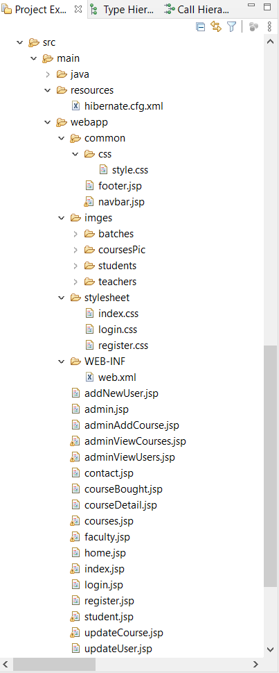

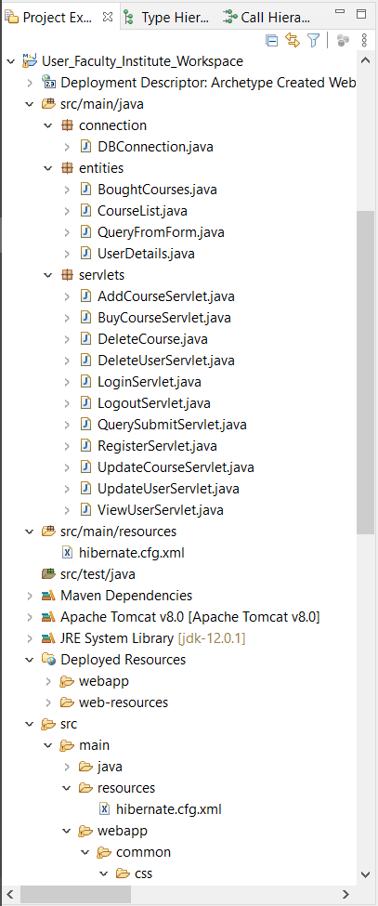

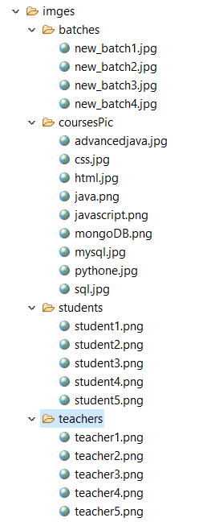

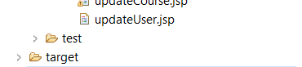

*Few Page can be added before project submission.

1. **Tables used (Screenshots of real table)**

UserDetails

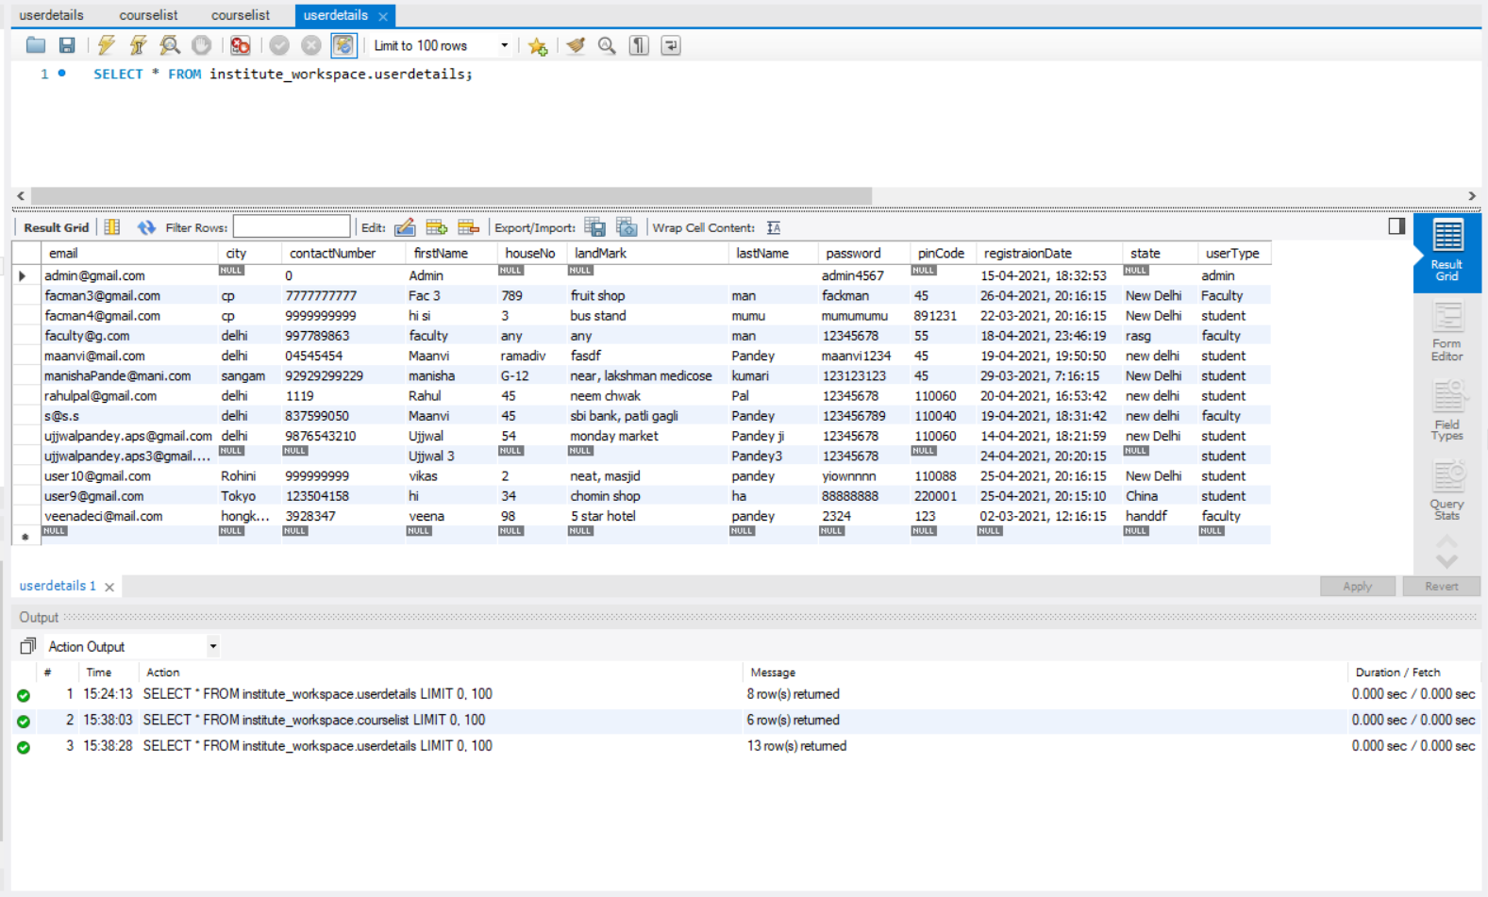

Courselist

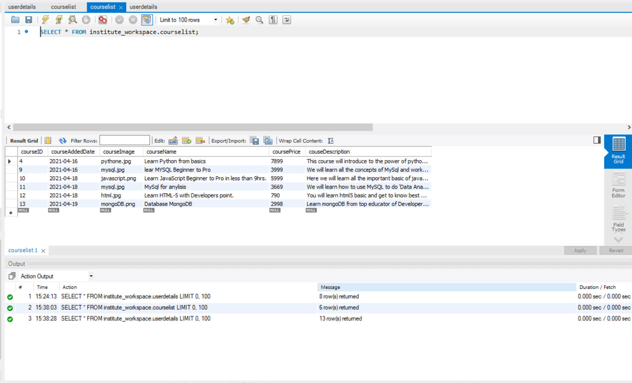

boughtcourses

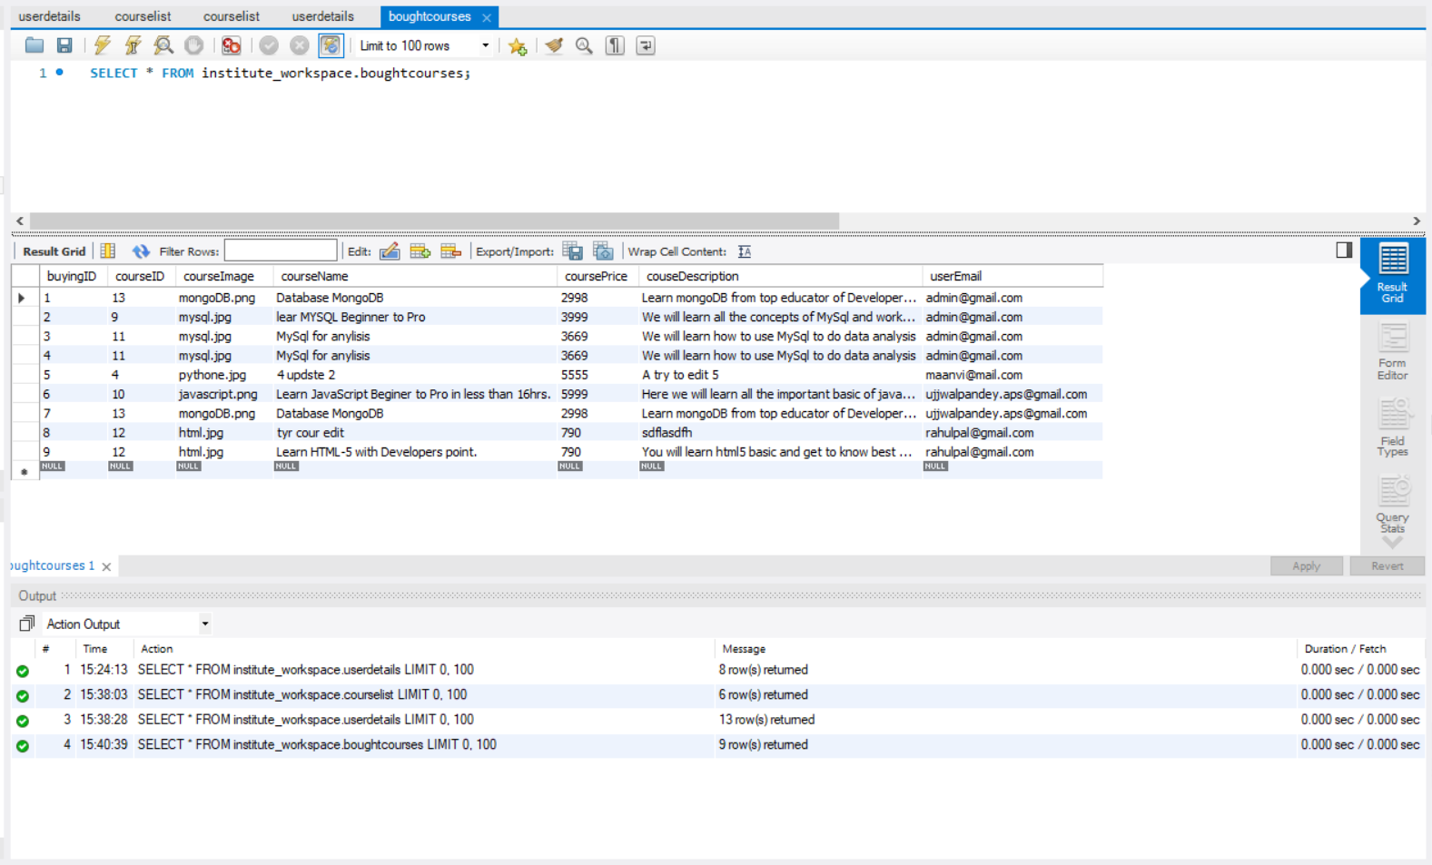

hibernate_sequence

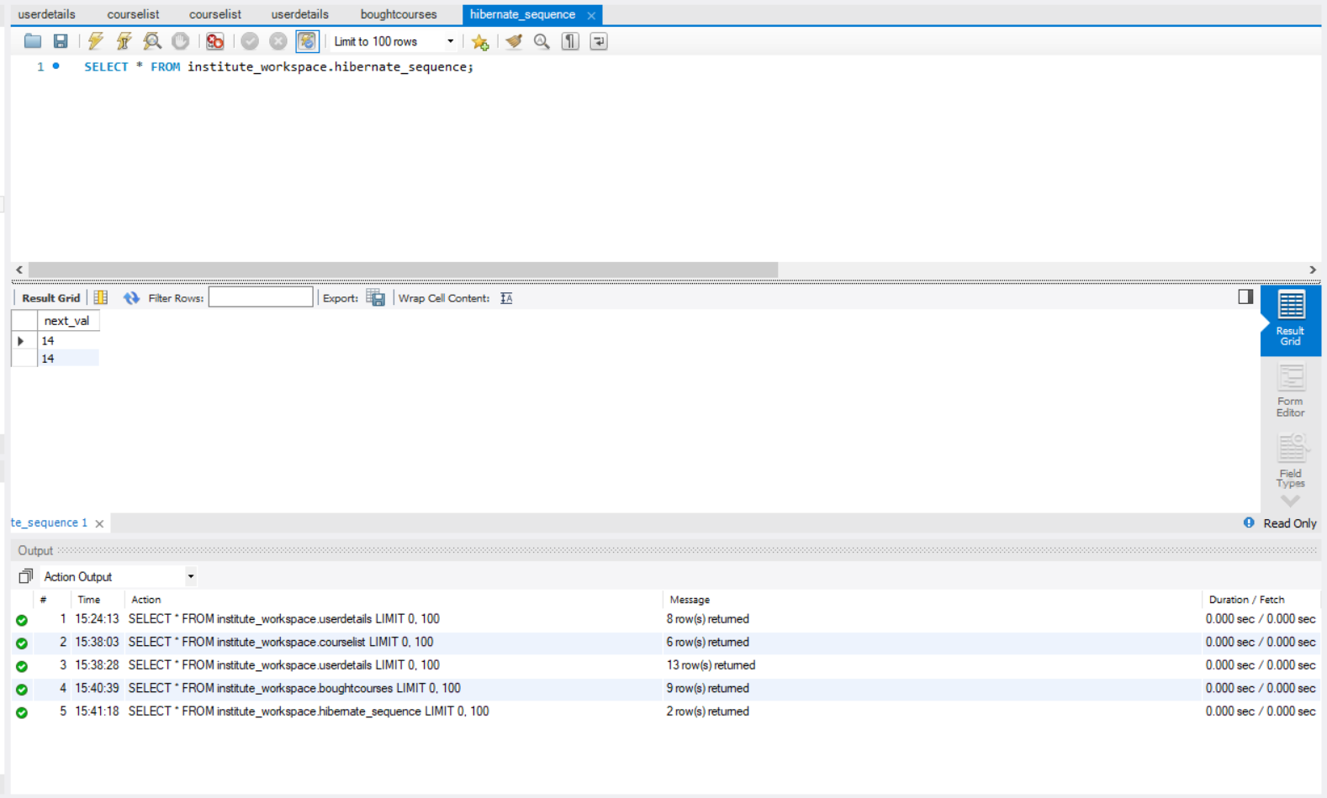

queryfromform

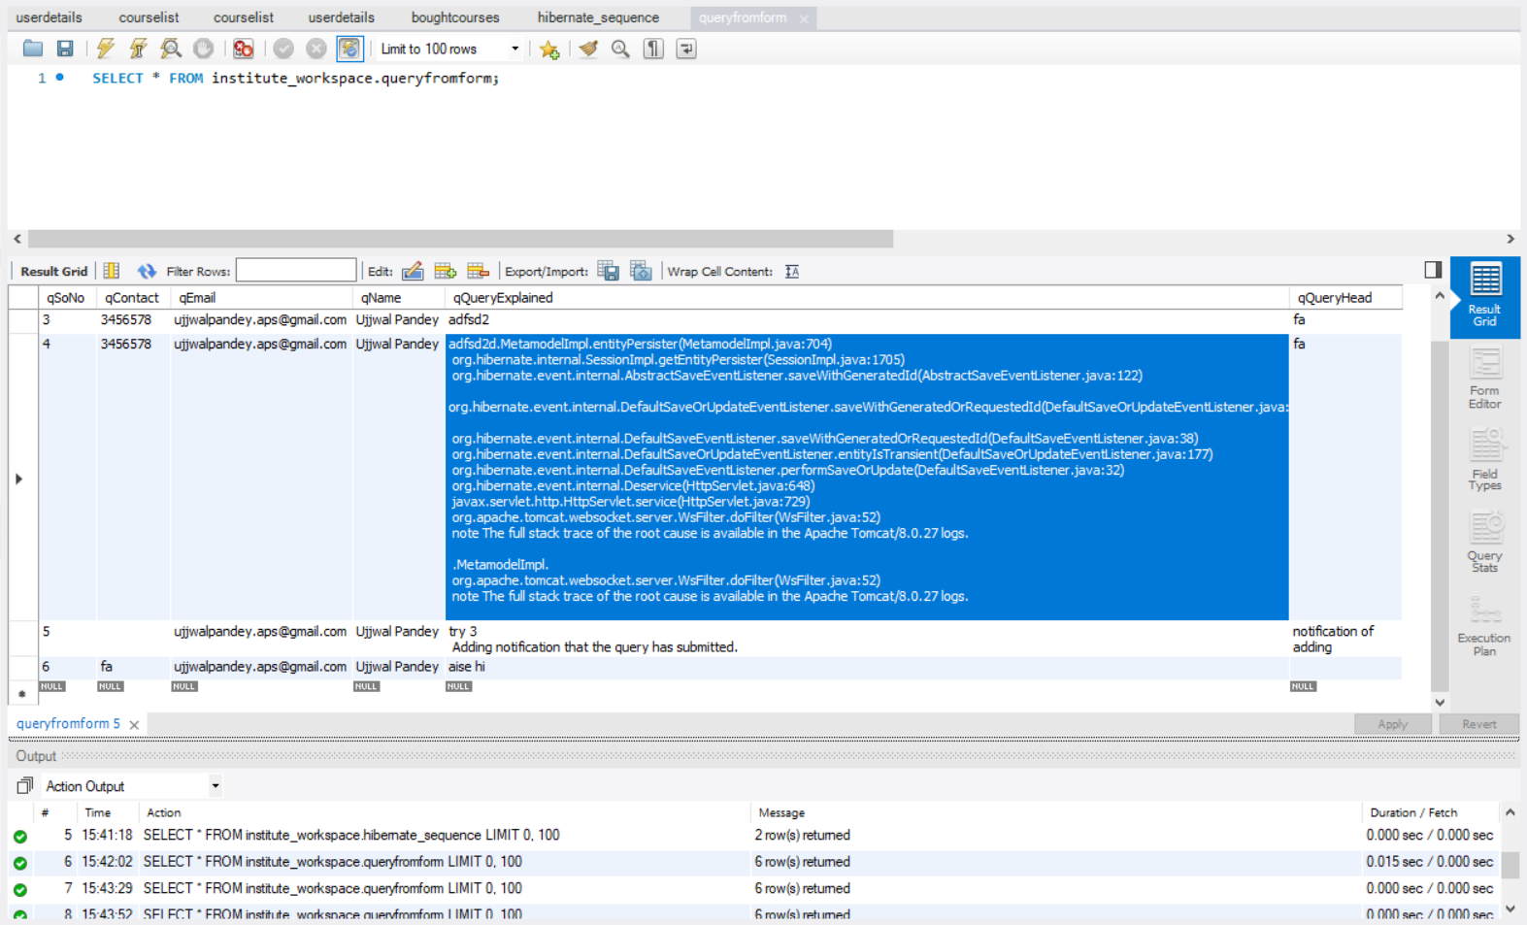

1. **Outputs**

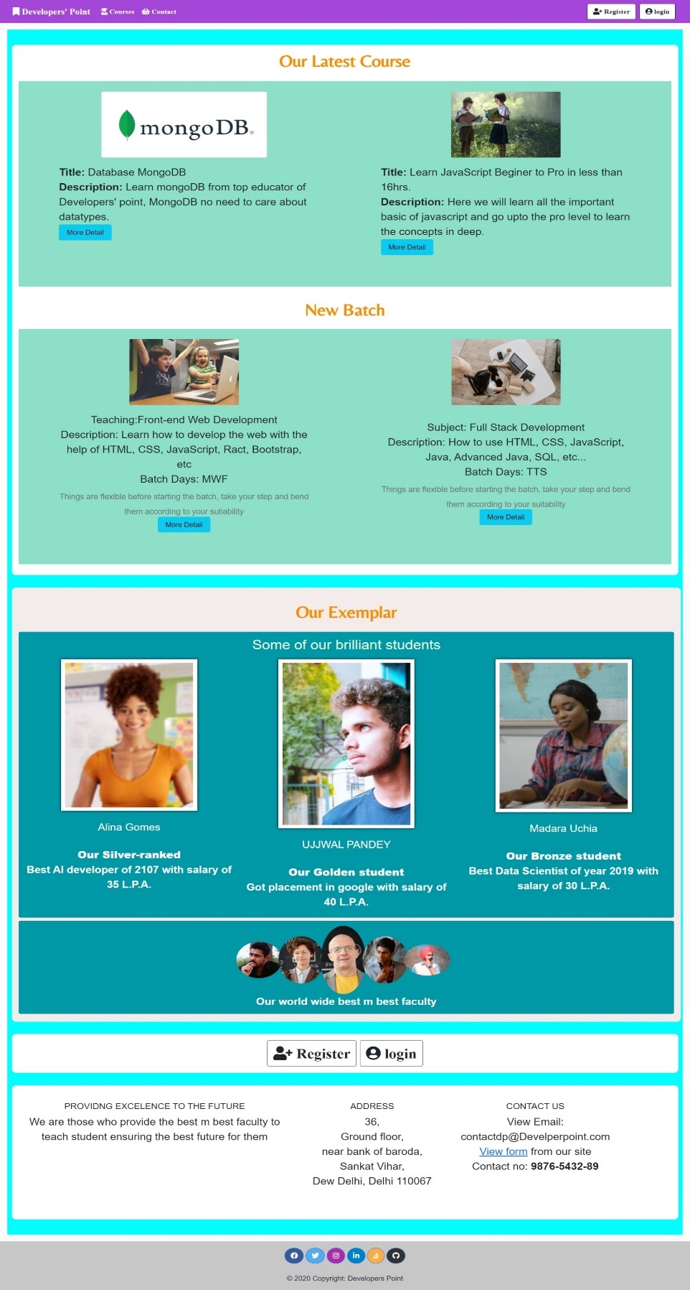

**Index page**

anyone can visit

(No login required)

Our latest course section is dynamic it shows latest added course.

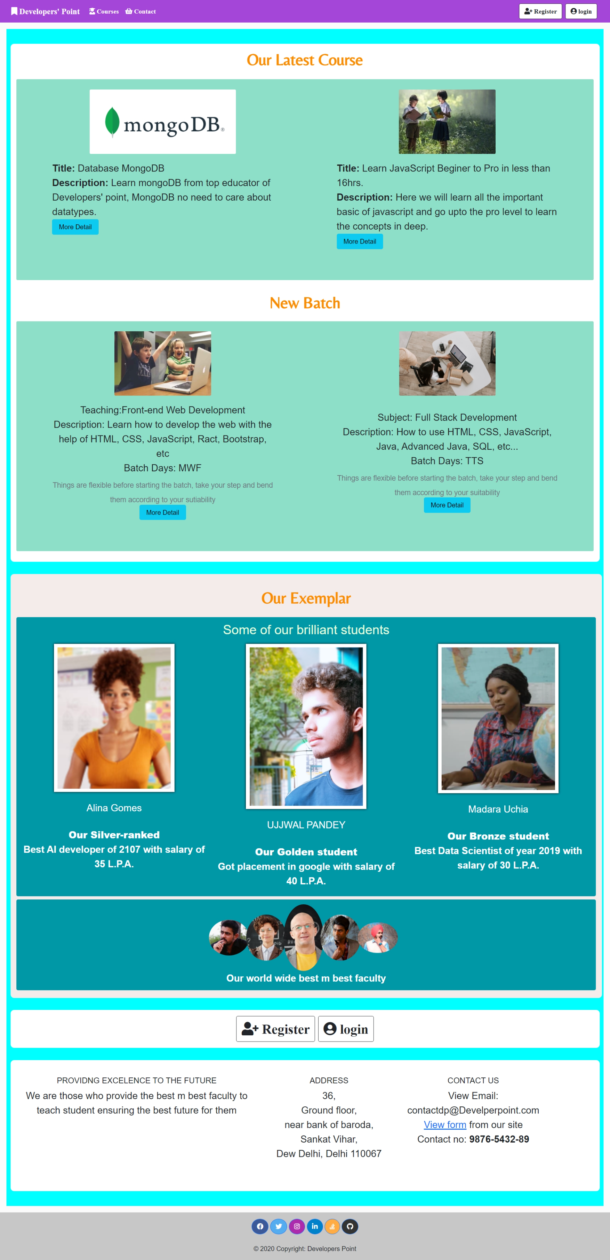

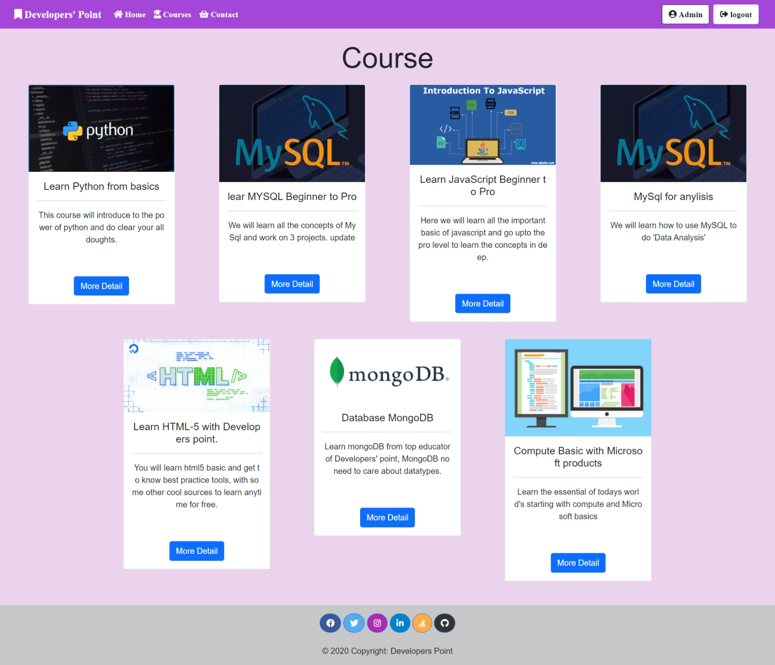

**Courses Page**

Anyone can come and search for courses

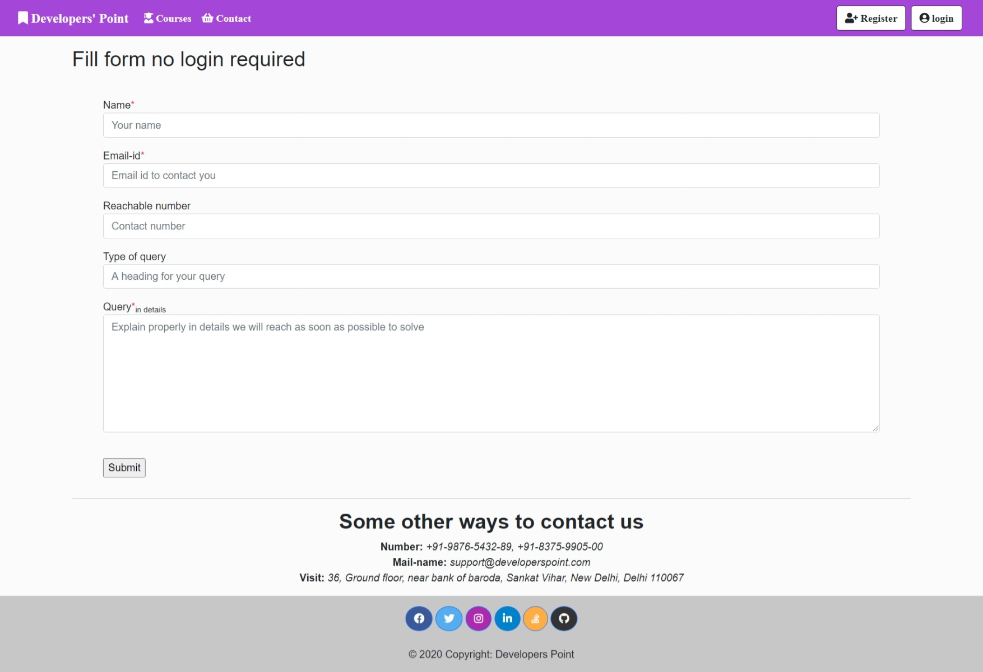

**Contact Page**

Anyone can come and contact institute on any query

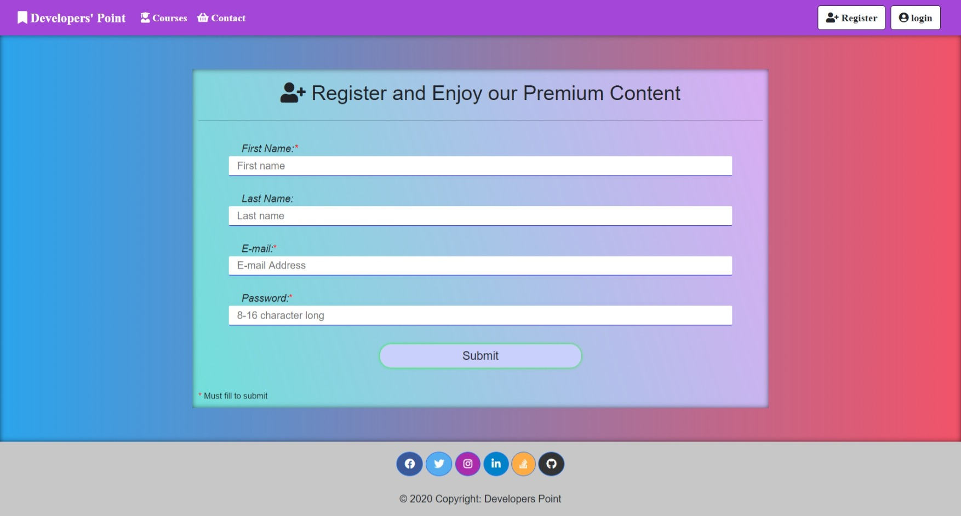

**Registration Page/Form demo**

Registering myself

On registration user gets a welcome mail, with initial details

**Registration Page/Form**

To access main features a person should register once

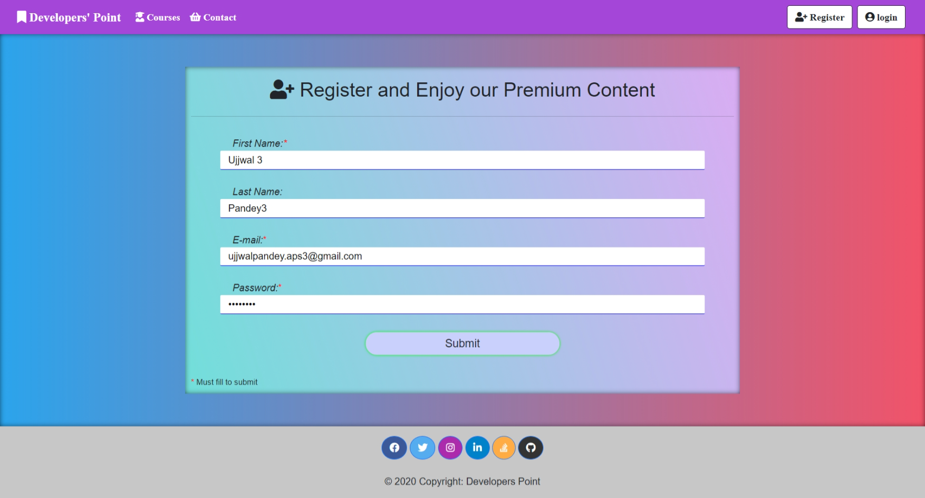

On successful registration user gets a mail.

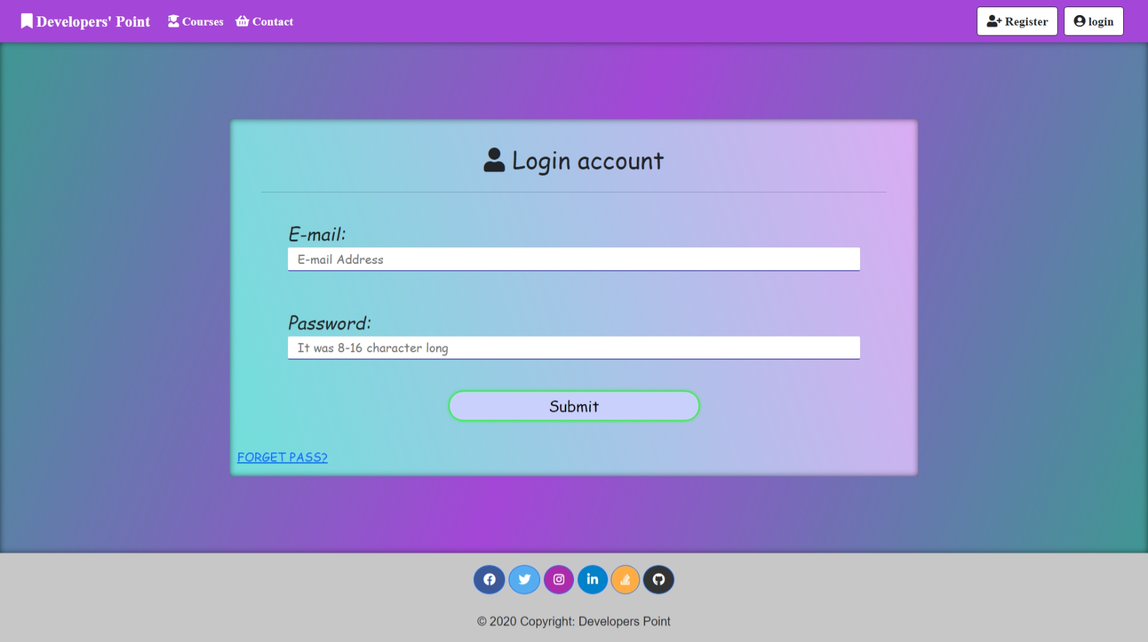

**Login Page/Form demo**

Logging as a student

**Login Page/Form**

To access main features a person should login.

Everyone (Student, faculty and admin)

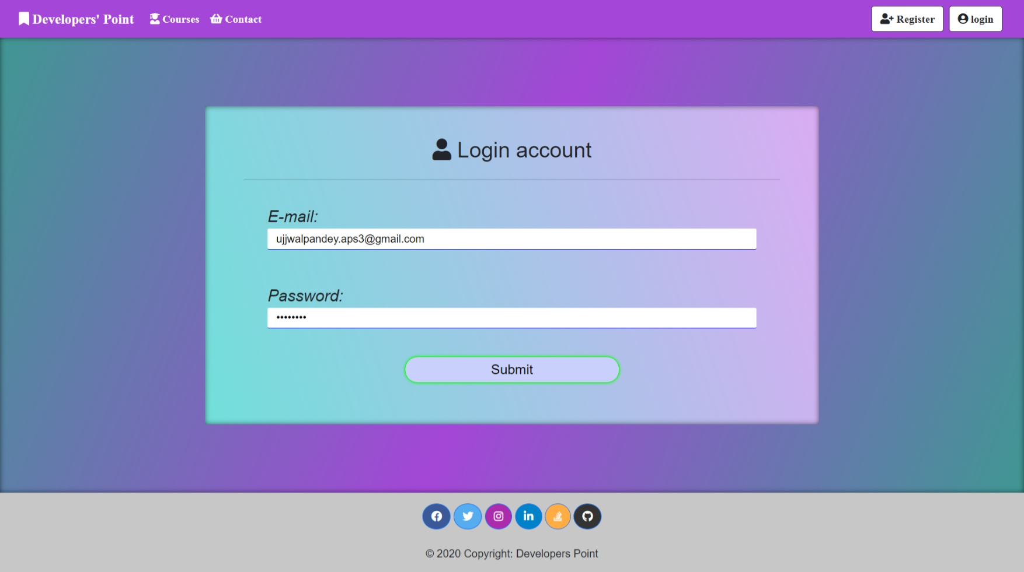

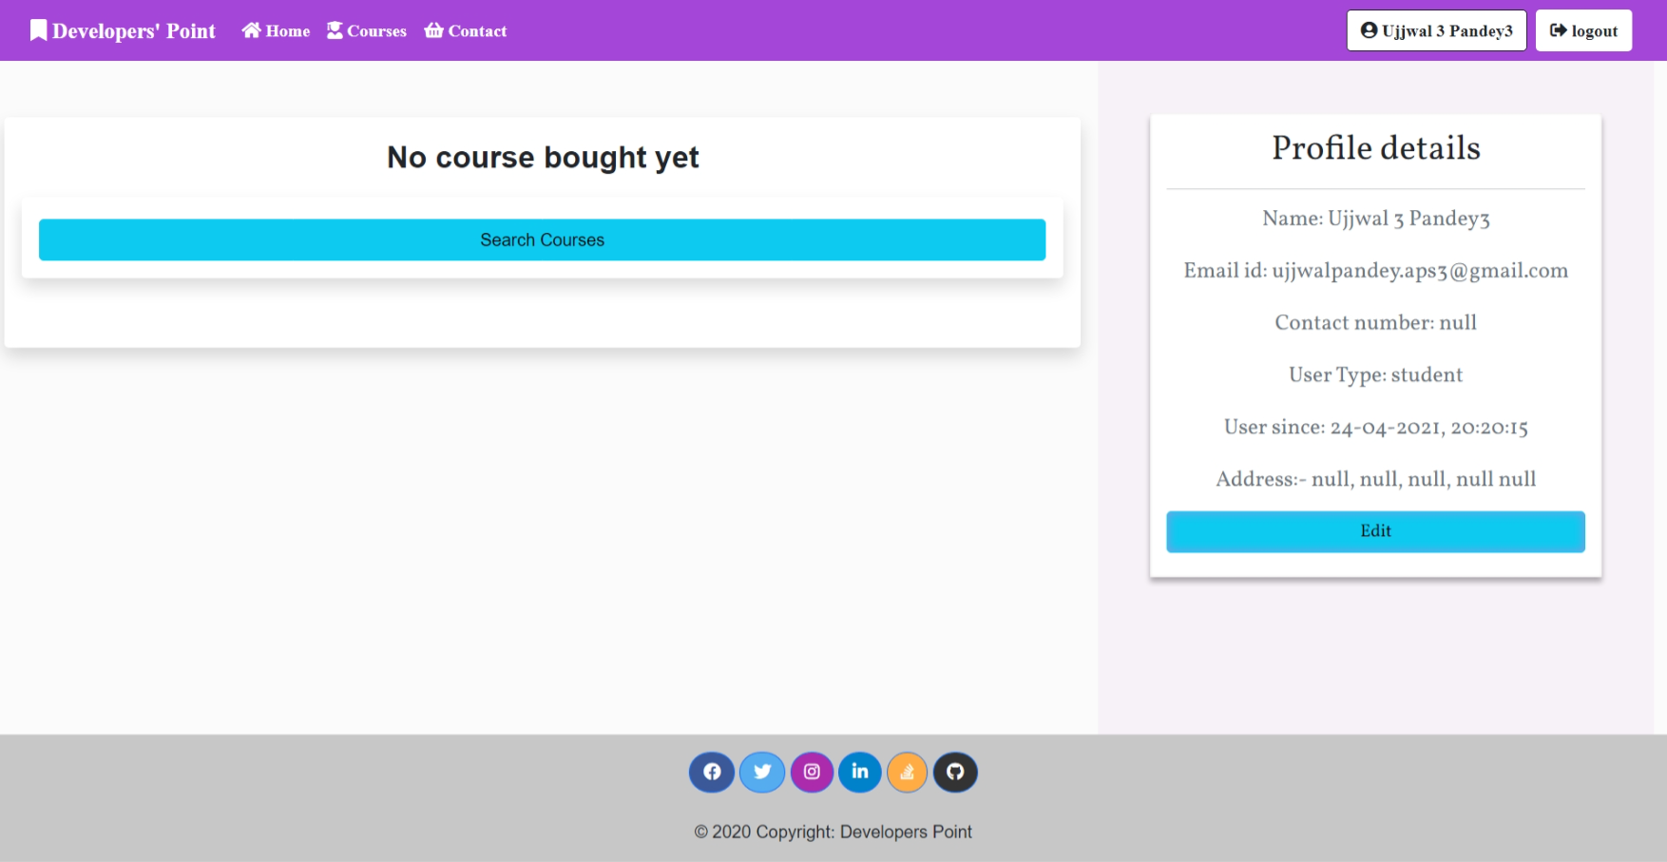

This will appear only when user don’t have a single course bought.

On click refer to the **Courses Page**

**‘Home Page’ of ‘Student’**

Logged in as student

When they haven’t bought ay course

When logged in this button appears

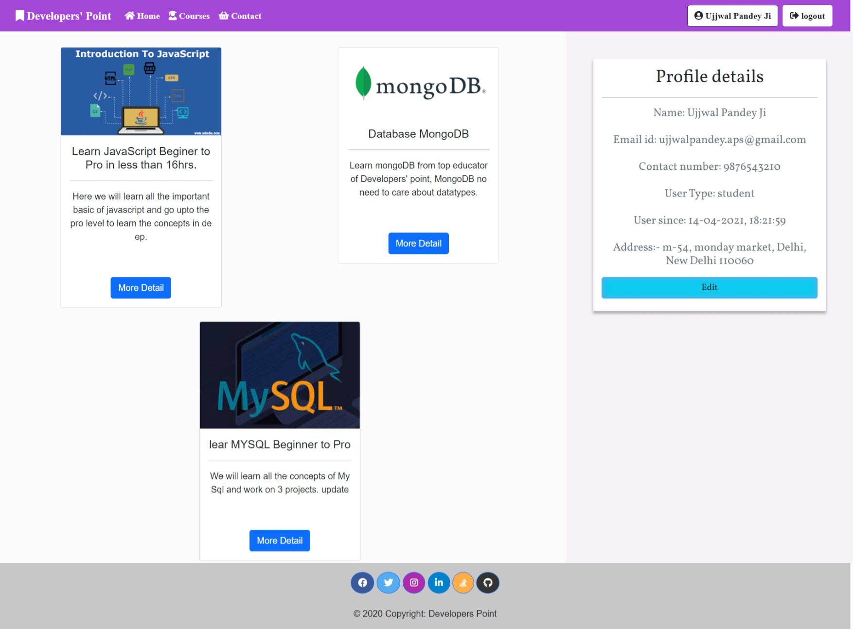

The page after the user (student/faculty) has bought at-least one course

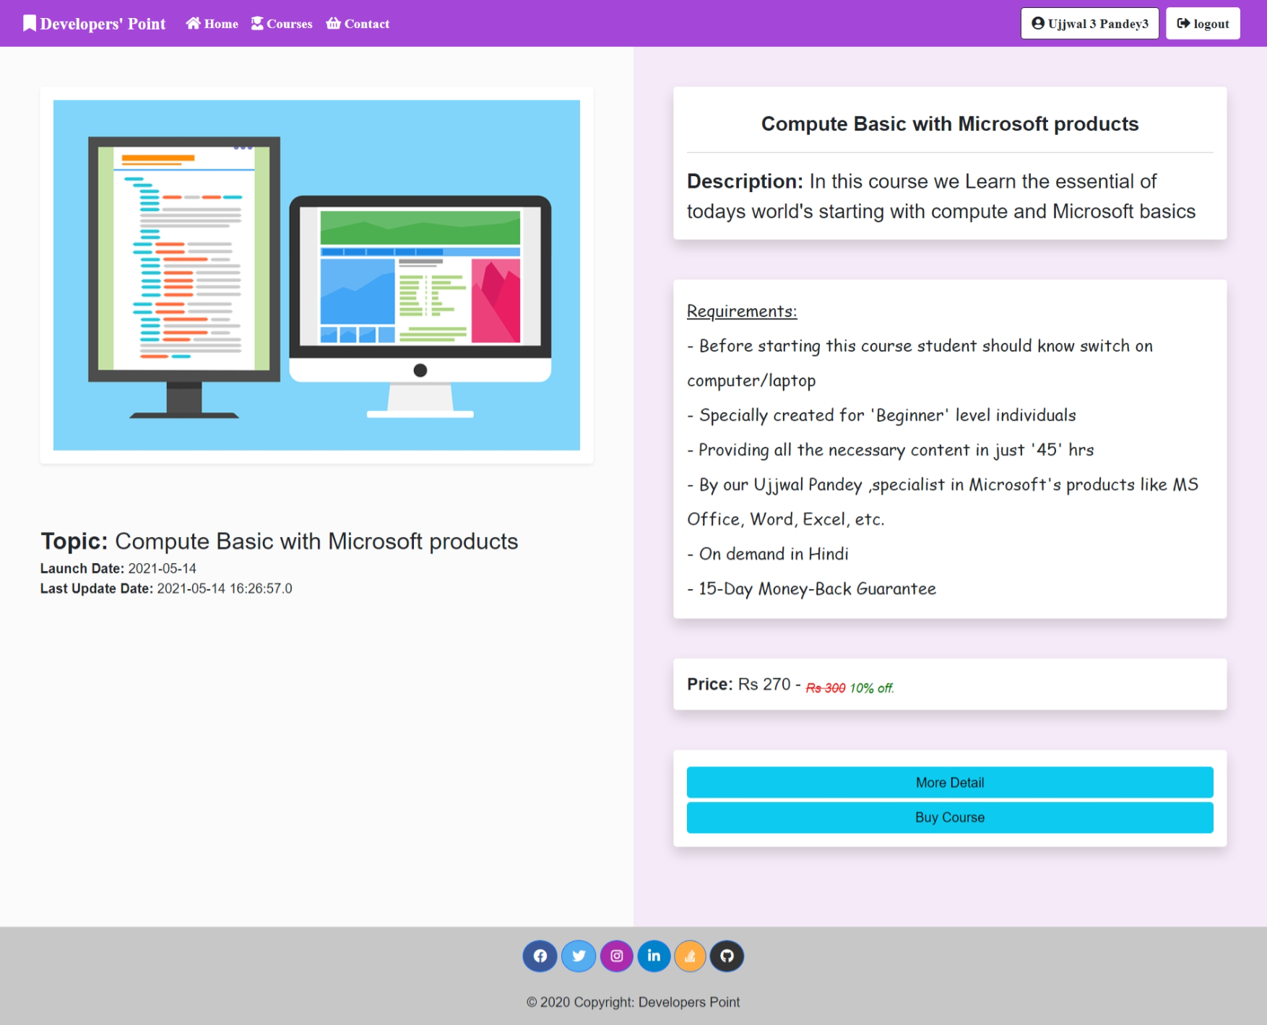

This button will take you to contact form.

From where you can ask for any required detail and institute management team will refer you back

**Course Details**

This page appears when a user clicks on view more details button of a courses card from all courses page

With this button you can buy the course by redirecting to payment gateway and pay they’re with different means

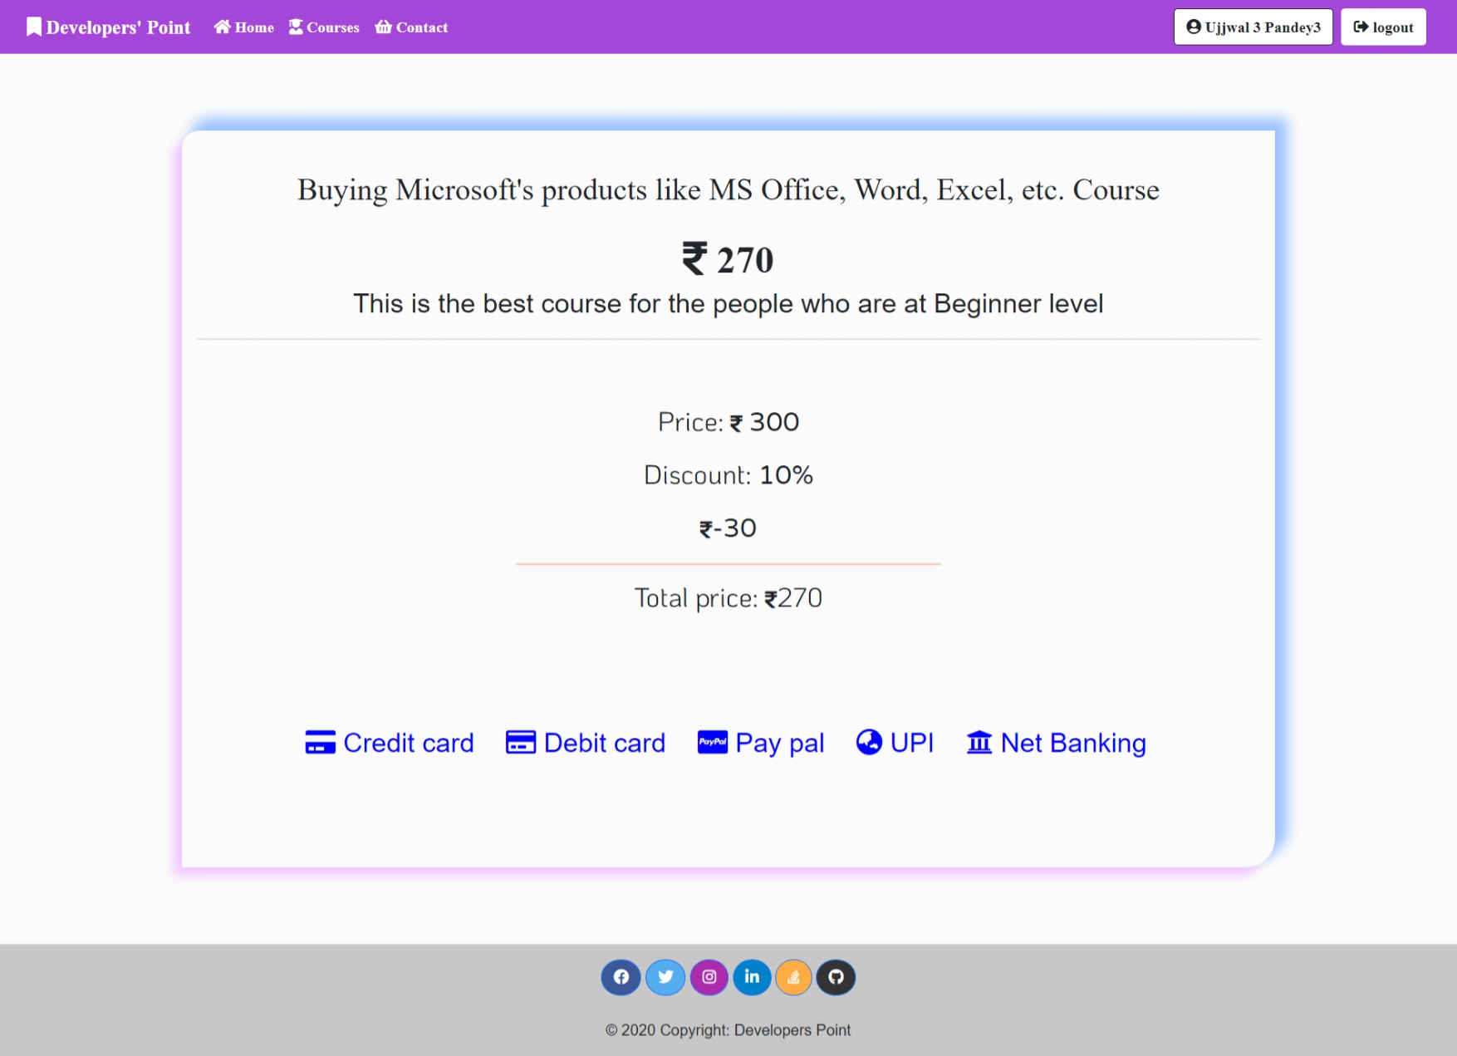

**Payment Ways**

All the payments proceeding are done in the same page, they opens’ separate modals showing area to fill details

**Payment Gateway**

This page is designed to show you the details a buyer wants to see without any interference.

This page have-five means of payment

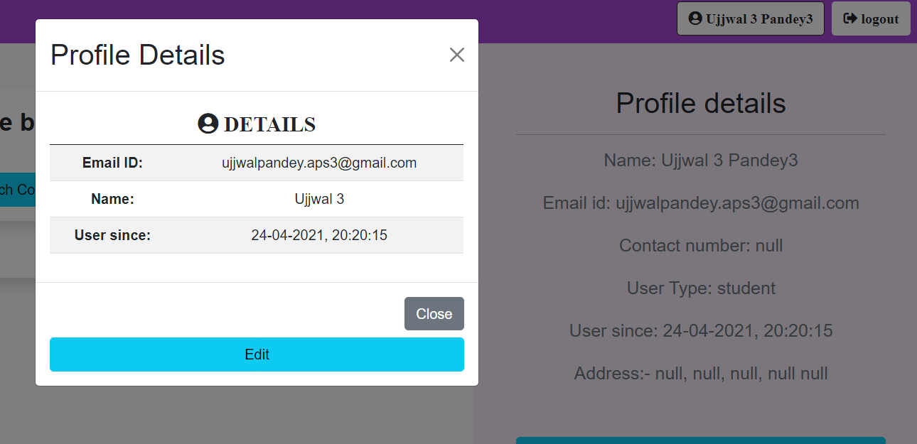

With this button on top-right corner,

On click it will open a model showing basic detail of a user and giving a button to update the profile details

Like the detail which is showing null fill it with real data

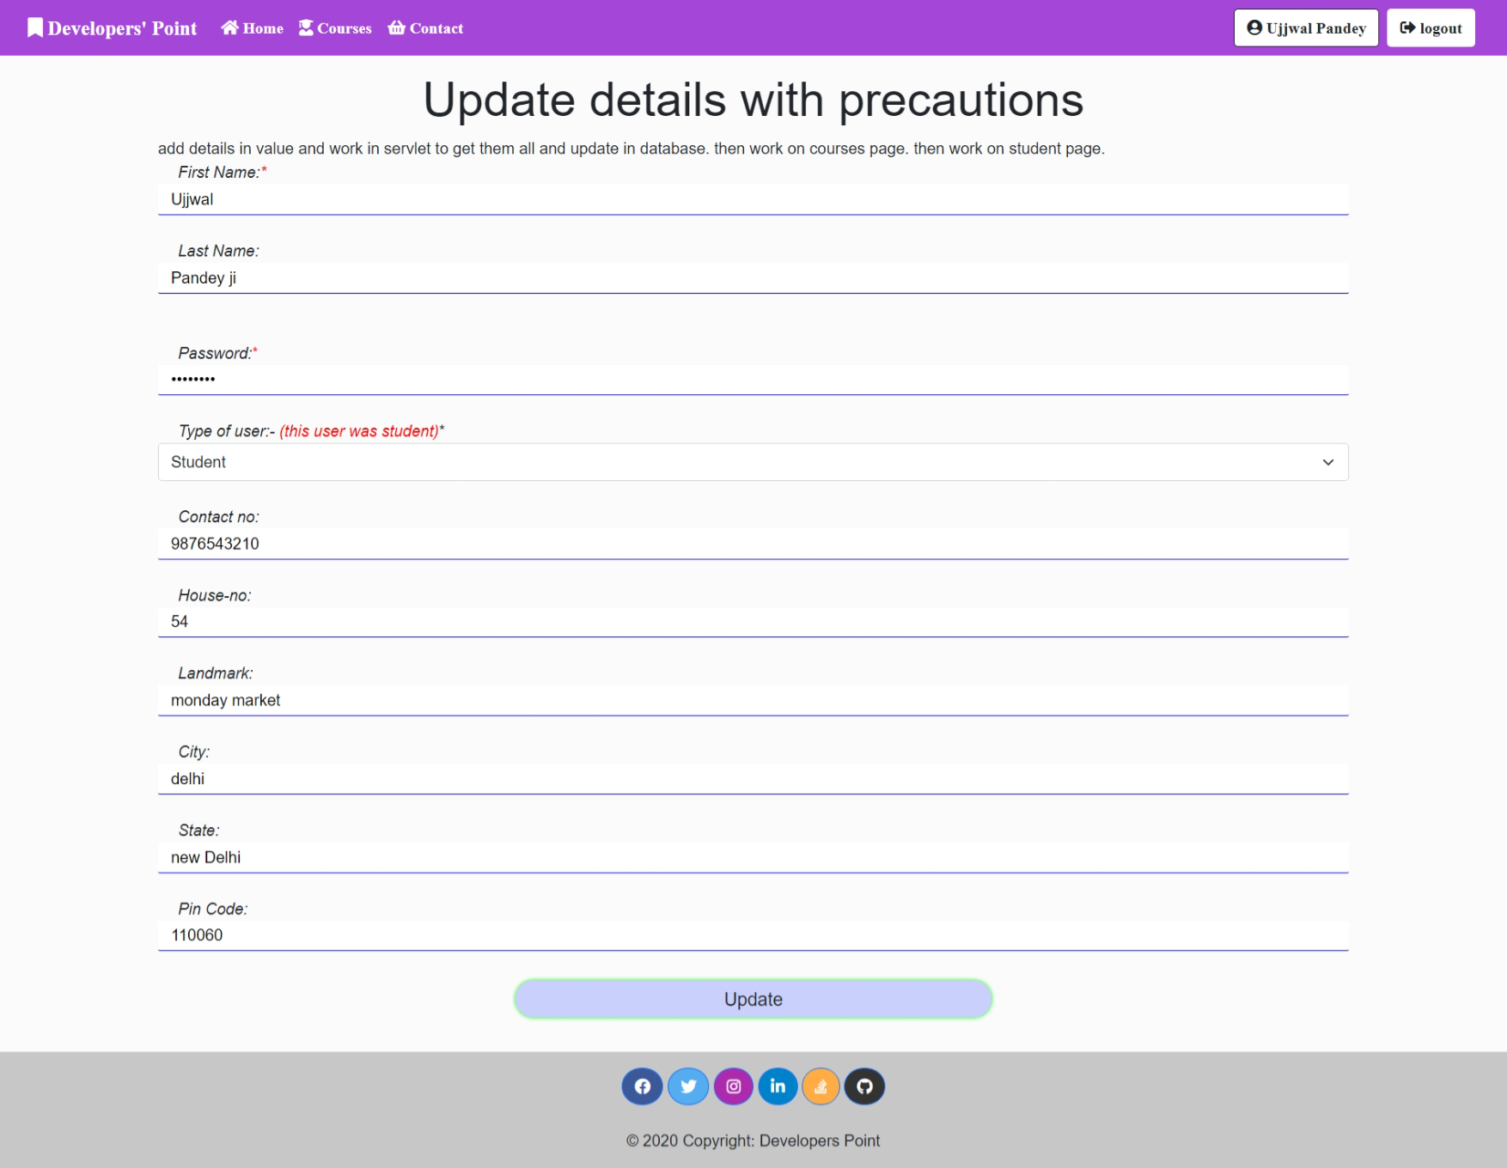

**Updating profile page**

***(Dynamic page)***

User can update its own profile here

It is an example too

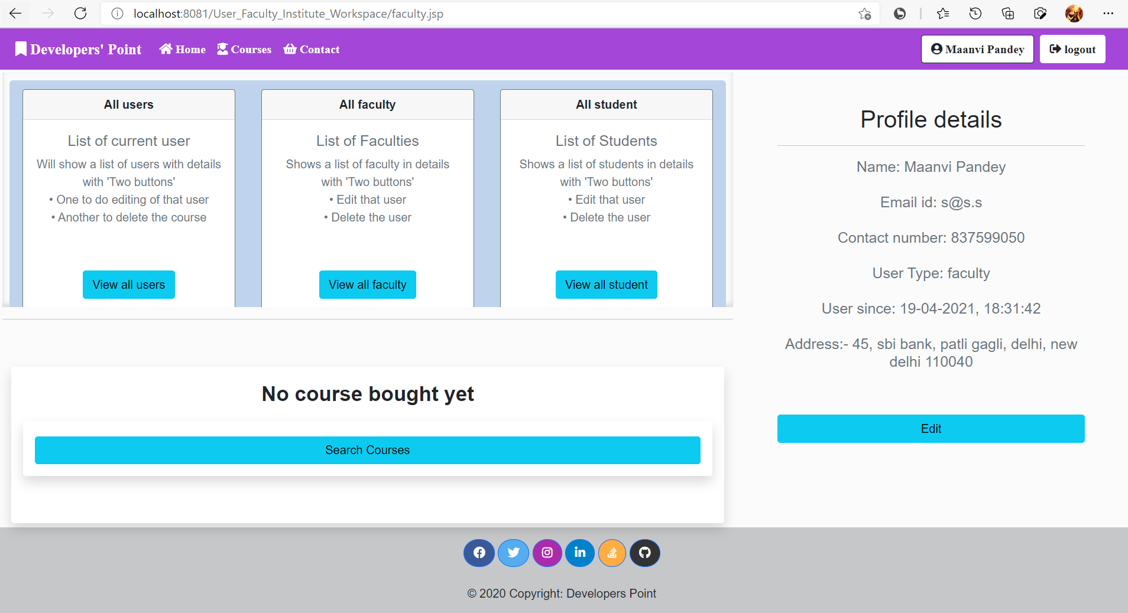

**Faculty Home page**

Logged in as Maanvi pandey

It is same as student page with extra **scrollable frame** of view others details.

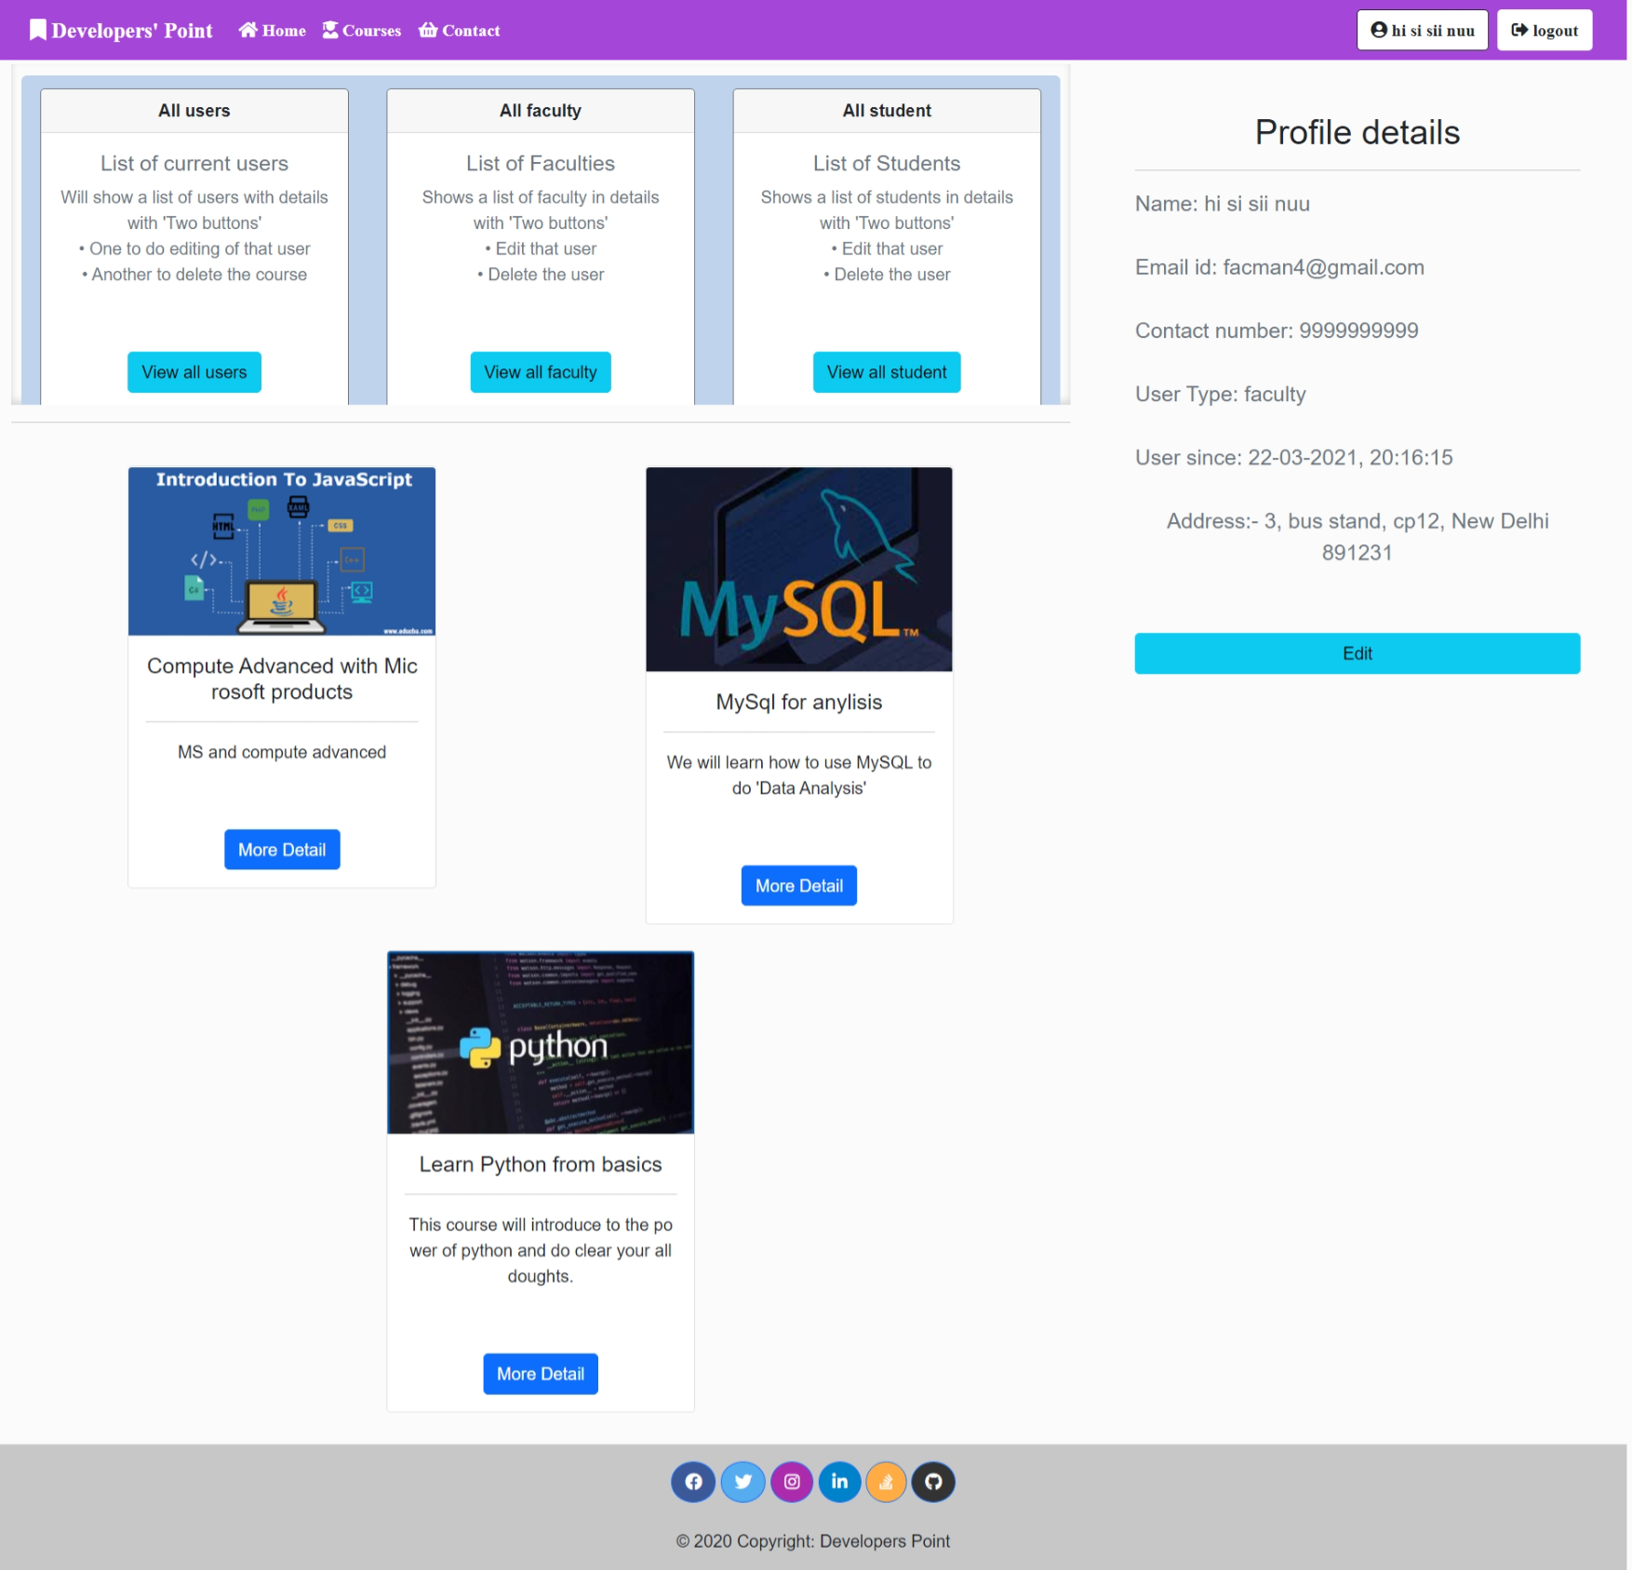

Faculty Home page after courses has been bought

List of bought courses

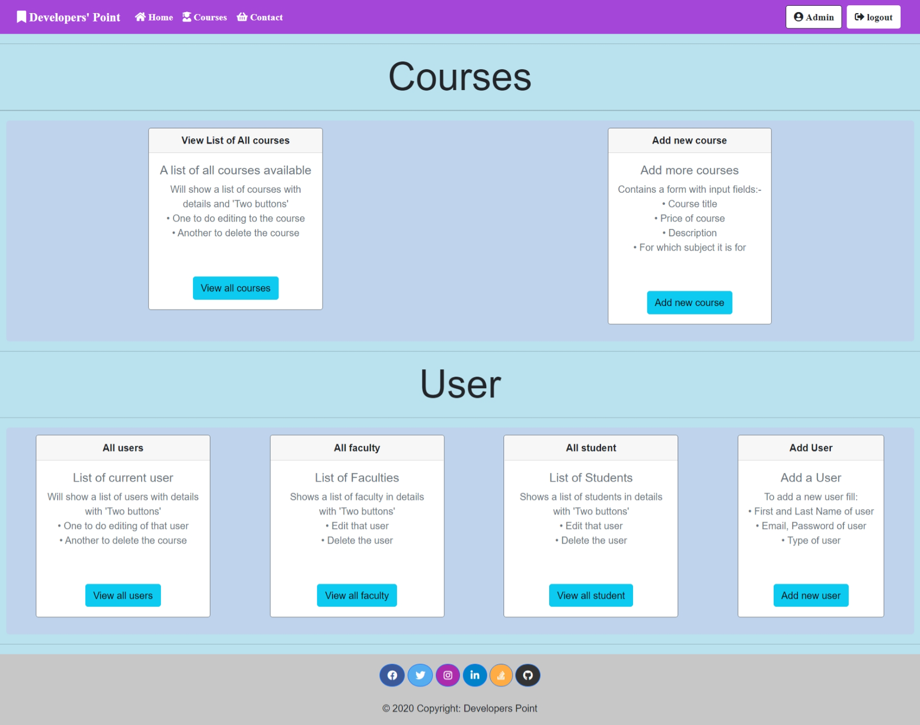

**An admin can do all the things specified in synopsis**

**Admin Home page**

Logged in as Admin

Completely different than

students and faculties

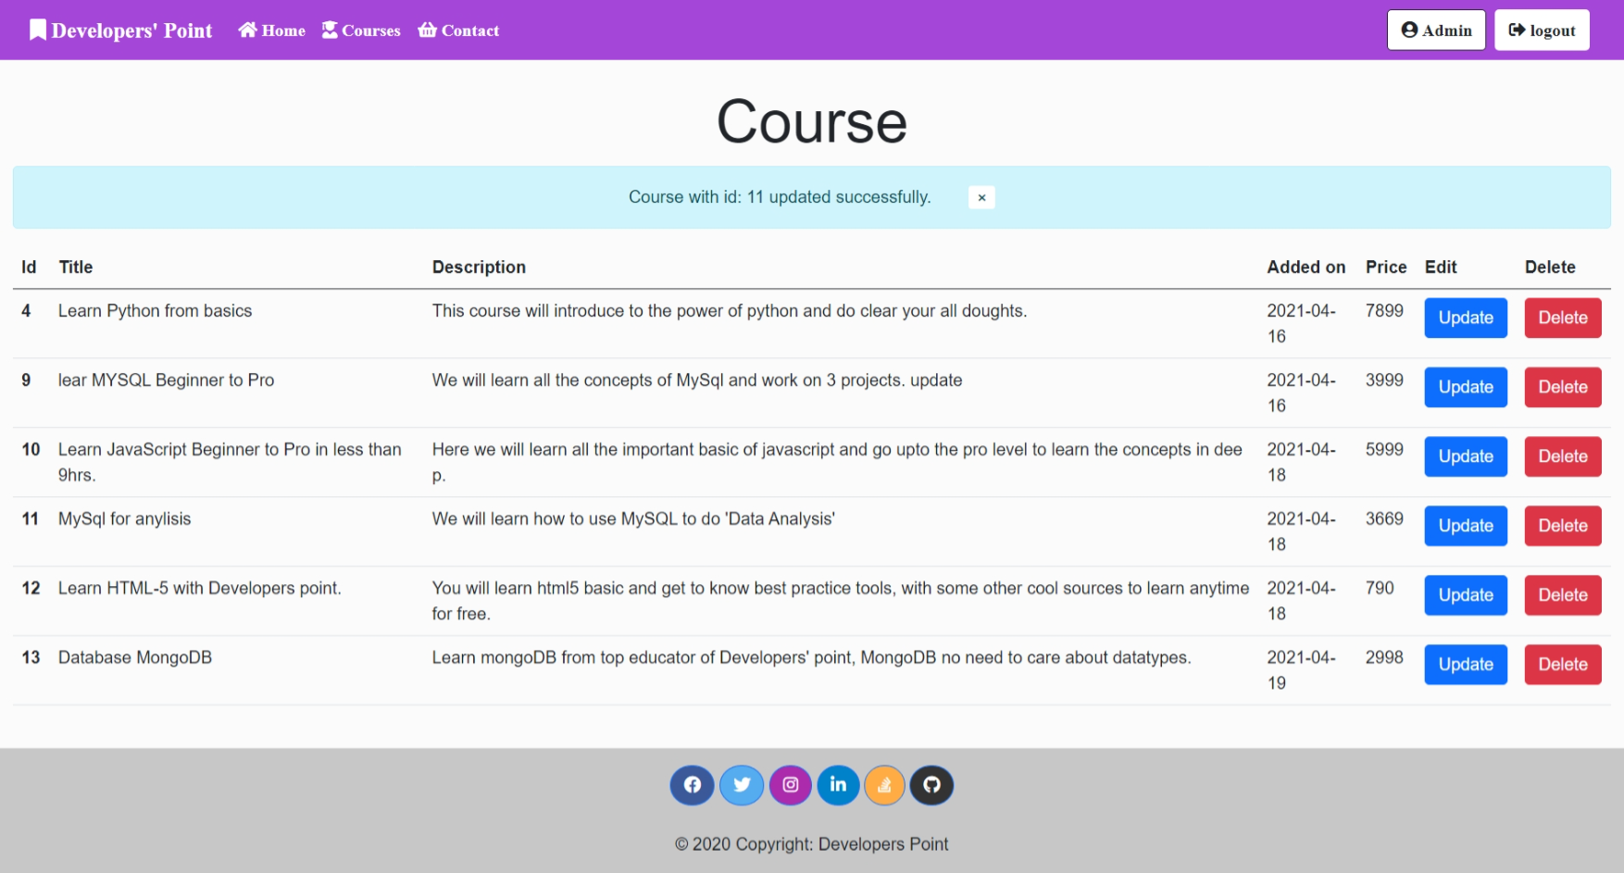

**View all Courses Page**

Admin can View the list of all the courses.

Admin can ‘delete’ and ‘update’ them also.

Blue line under word course will appear when admin has updated any course

Disappear after one time show

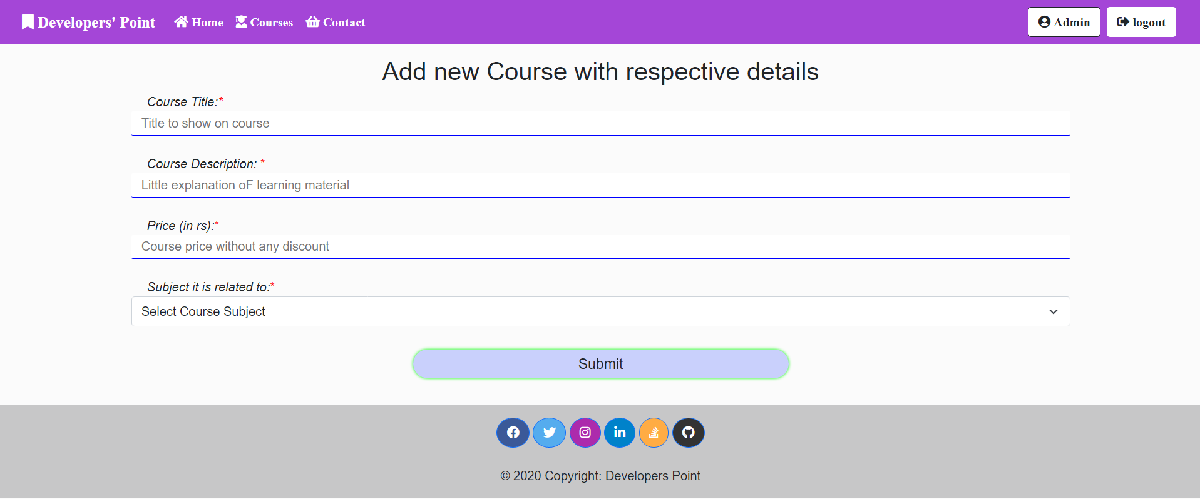

**Add new Course Page**

This page will allow admin to add new course at a time

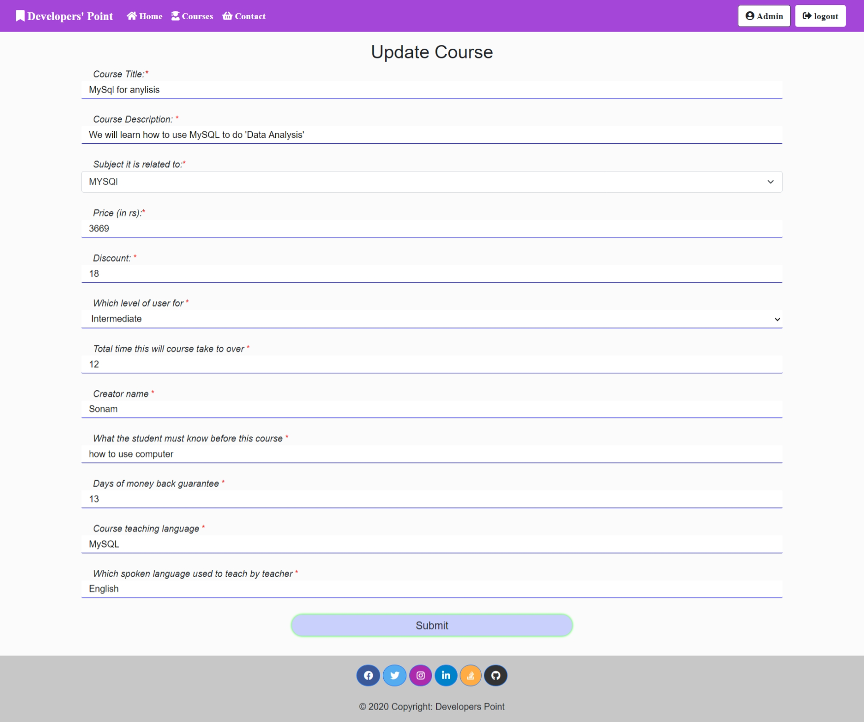

**Update Course Details Page**

This page will allow admin to View, edit any Course details

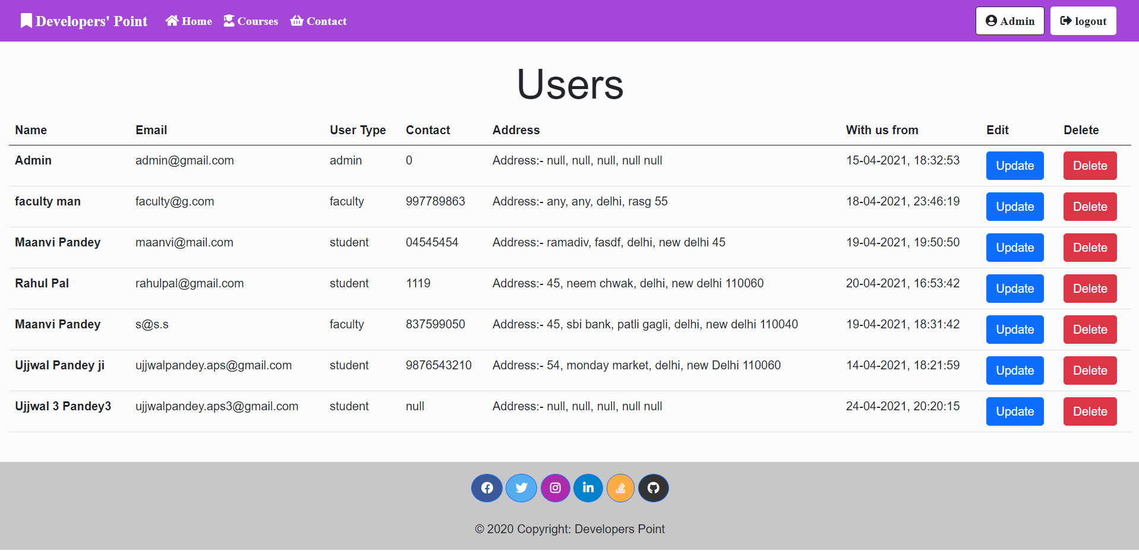

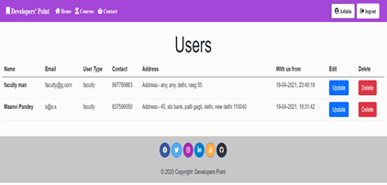

All type of users

**View all Users Page**

This page will allow admin to View, edit and delete any user dynamically

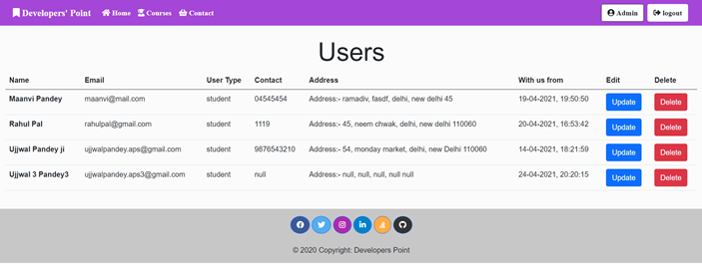

Only faculty

Only students

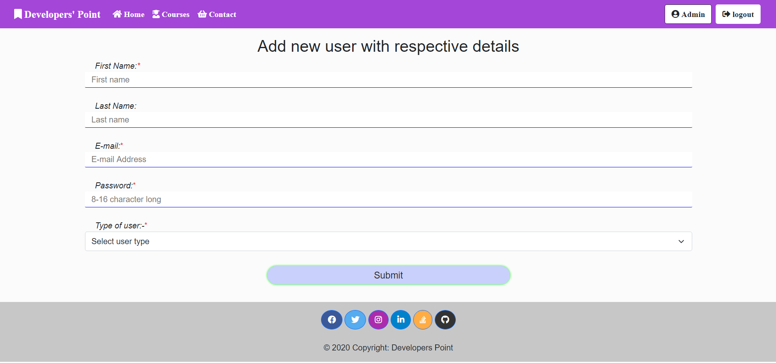

**Add new User (by Admin) Page**

This page will allow admin add new user and assign their role of student, admin or faculty

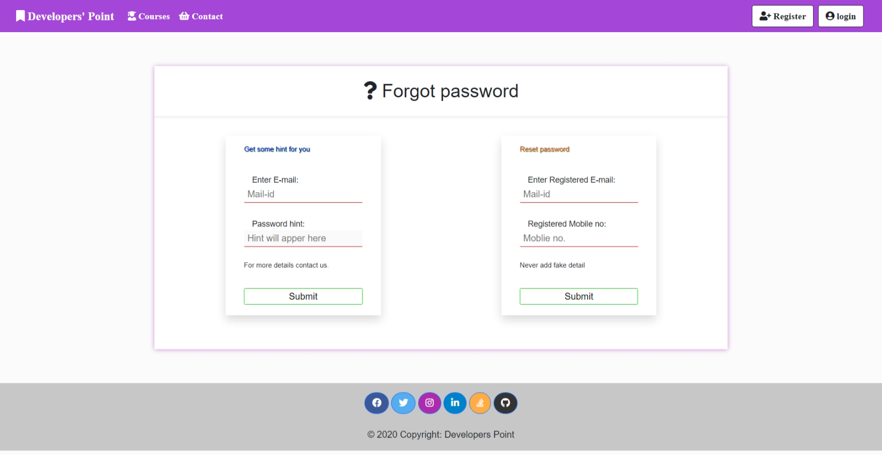

**Forget Password page**

This page has 2 finicalities,

1. Get some hint about password,
2. Receive a mail with the details

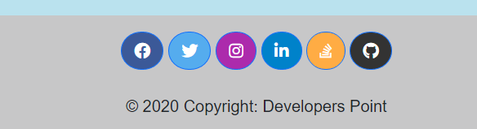

**In Footer**

In footer (available on each and every page) all these icons visible are not only icons they are click and referred to actual my profiles

**BIBLIOGRAPHY**

# *WEBSITEs* used to get help while creating projects –

1. [www.google.com](http://www.google.com)
2. <http://www.microsoft.com/en-in/download/>
3. <https://www.javatpoint.com/mysql-tutorial>
4. <https://app.creately.com/diagram/IZYu0470DJu/edit>
5. [https://lucid.app/lucidchart/9e136d93-4545-4cd1-b26f-8bb69ac6484d/edit?beaconFlowId=E7D9D2D1265439AA&page=0_0#](https://lucid.app/lucidchart/9e136d93-4545-4cd1-b26f-8bb69ac6484d/edit?beaconFlowId=E7D9D2D1265439AA&page=0_0)
6. Many channels and videos from youtube.

**Referenced Books**

1. All books of NIIT (I am a student of NIIT). They taught me:
   1. Core java
   2. Advanced java
   3. RWD
   4. RDBMS
   5. MYSQL
   6. JSP
   7. HIBERNATE
2. IGNOU Blocks

referenced books (SQL Server 2005)–

1. Leonard Lobal, *Andrew J. Brust, Stephen Forte, Programming Microsoft SQL Server 2005 (Pro Developer),* 29 Oct 2008
2. Robert Vieira, *Professional Microsoft SQL Server 2005 Programming,* 23 Aug 2009
3. IGNOU Blocks